**Lab Sheet - Fully Associative Cache**

**Objectives**

At the end of this lab session, the student should be able to:

* Understand fully associative mapped cache
* Understand the behaviour of fully associative mapped cache by varying block size and cache size
* Understand the behaviour of fully associative mapped cache concerning replacement algorithms

**Prerequisites:** Module No. 4 - Cache Memory Organization

**6.0 Performance Analysis of Fully Associative Mapped Cache**

The following program should be used to analyse a fully associative mapped cache.

LDB 00, R00

LDB 01, R01

LDB 02, R02

LDB 03, R03

LDB 04, R04

LDB 05, R05

LDB 06, R06

LDB 07, R07

LDB 08, R08

LDB 09, R09

LDB 10, R10

LDB 11, R11

LDB 12, R12

LDB 13, R13

HLT

Press the “Cache-Pipeline” tab and select the cache type as “data cache”, as shown in Figure 1. Press the “Show Cache…” button. A new window will be opened, which is shown in Figure 2.

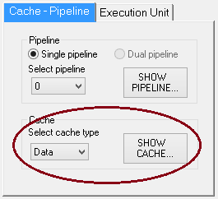

**Figure 1: Cache – Pipeline setting**

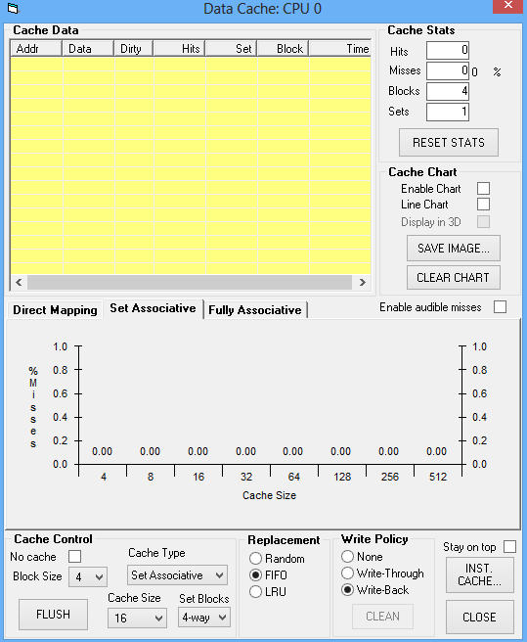

**Figure 2: Data cache window**

**Problem 1 :**

Step 1: Set the following parameters in the cache control block of the data cache window, as shown in Figure 2.

* Block Size: 2
* Cache Type: Fully Associative
* Cache Size: 16 bytes
* Select Enable Chart check box
* Select stay on top check box
* Replacement: Random

Step 2: Run the program in a single step and observe the changes on the data cache window

Step 3: Note down the number of hits, misses and hit ratio

**Problem No 2:** Analysis of Fully associative cache by varying block size.

Set the following parameters:

* Cache Type: Fully associative cache
* Cache Size: 16 bytes
* Select Enable Chart check box
* Select stay on top check box

Execute the above program by setting a block size to 2, 4, 8, 16 and 32. Record the observation in the following table.

|  |  |  |  |  |
| --- | --- | --- | --- | --- |
| Block Size | Cache Size | Miss | Hit | Miss ratio |
| 2 | 16 | 7 | 7 | 0.5 |
| 4 | 16 | 4 | 10 | 0.285 |
| 8 | 16 | 2 | 12 | 0.142 |
| 16 | 16 | 1 | 13 | 0.0714 |
| 32 | 32 | 1 | 13 | 0.0714 |

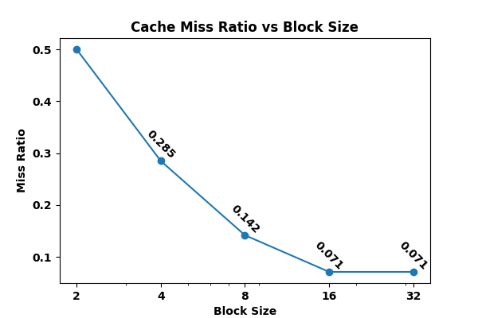

# Figure 3: Graph of Cache miss ratio Vs Block size for problem no. 2

**Problem No 3:** Analysis of fully associative cache by varying cache size.

Set the following parameters:

* Block size: 2
* Cache Type: Fully associative cache
* Select Enable Chart check box
* Select stay on top check box
* Replacement: Random

Execute the above program by setting a block size to 2, 4, 8, 16 and 32. Record the observation in the following table.

|  |  |  |  |  |
| --- | --- | --- | --- | --- |
| Block Size | Cache size | Miss | Hit | Miss ratio |
| 2 | 4 | 14 | 14 | 0.5 |
| 2 | 8 | 7 | 7 | 0.5 |
| 2 | 16 | 7 | 7 | 0.5 |
| 2 | 32 | 7 | 7 | 0.5 |
| 2 | 64 | 7 | 7 | 0.5 |

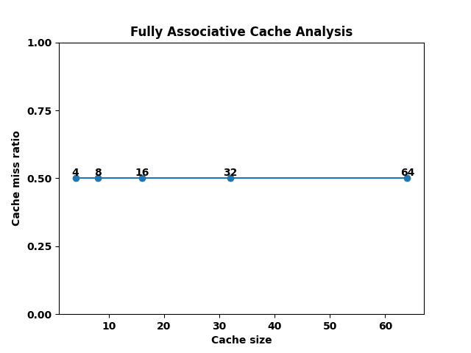

**Figure 4: Graph of Cache miss ratio Vs Cache size for problem no. 3**

**Problem No 4:** Analysis of fully associative cache concerning replacement algorithm.

Set the following parameters:

* Block size: 4
* Cache size: 8
* Cache Type: Fully associative cache
* Select Enable Chart check box
* Select stay on top check box

Execute the above program by setting the replacement algorithm as FIFO, Random and LRU. Record the observation in the following table.

|  |  |  |  |
| --- | --- | --- | --- |
| Replacement Algorithm | Miss | Hit | Miss ratio |
| FIFO | 4 | 10 | 0.285 |
| LRU | 4 | 10 | 0.285 |
| Random | 4 | 10 | 0.285 |

Are the results obtained identical for all the cases? Justify your answer.

Yes, the results obtained are identical for all the cases. The miss, hit, and miss ratio values are the same for all replacement algorithms used in the program. This suggests that for the given block size and cache size, the replacement algorithm does not have a significant impact on cache performance. However, it is important to note that this may not always be the case, and different replacement algorithms may have varying impacts on cache performance depending on the access patterns of the memory being used.

**Problem No 5:** Analysis of fully associative cache concerning replacement algorithm.

Set the following parameters:

* Block size: 4
* Cache size: 8
* Cache Type: Fully associative cache
* Select Enable Chart check box
* Select stay on top check box
* Save integer numbers from 0 to 40 in the main memory 0000 to 0040.

Execute the following program by setting the replacement algorithm as FIFO, Random and LRU. Record the observation in the following table.

LDB 01, R00

LDB 16, R01

LDB 32, R02

LDB 00, R03

LDB 16, R04

LDB 16, R05

LDB 32, R06

LDB 08, R07

LDB 04, R08

HLT

|  |  |  |  |
| --- | --- | --- | --- |
| Replacement Algorithm | Miss | Hit | Miss ratio |
| Random | 28 | 8 | 0.777 |
| FIFO | 8 | 1 | 0.888 |
| LRU | 8 | 1 | 0.888 |

Are the results obtained identical for all the cases? Justify your answer.

No, the results obtained are not identical for all the cases. The miss ratio obtained for each replacement algorithm is different. For example, the miss ratio obtained for the Random replacement algorithm is lesser compared to the other two algorithms. This is because the Random replacement algorithm selects a random block to replace, which may not be the least recently used or the oldest block. On the other hand, the FIFO and LRU replacement algorithms replace the least recently used block and the oldest block, respectively, which can lead to a lower hit rate and higher miss ratio. Therefore, the choice of replacement algorithm can have a significant impact on the performance of the cache system.